

MINISTRY OF EDUCATION
THE STATE DEPARTMENT TECHNICAL VOCATIONAL EDUCATION AND TRAINING

ROBOKEN 2023 RULES
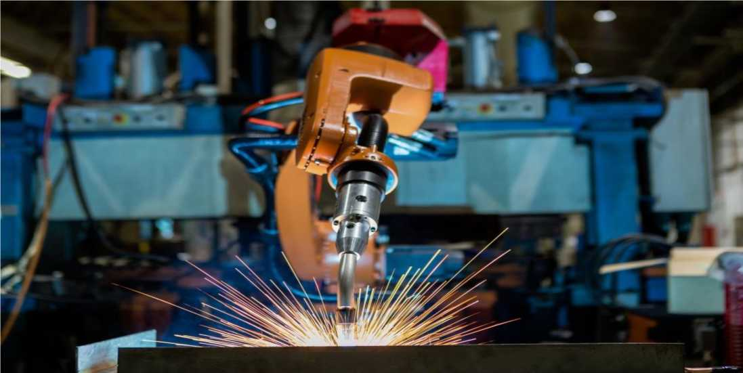

ROBOTS IN MANUFACTURING

PREAMBLE
The first industrial robot was developed by George Devol, an American inventor and founder of the first robotic company. In Kenya robotic contests have been successfully conducted yearly since 2008 under the Ministry of Education, State Department of Vocational and Technical Training, with the support of Nagasaki University in Japan. These contests have attracted the participation of National Polytechnics, Technical Training Institutes, Institutes of Science & Technology, Technical Vocational Colleges, Local Universities and some institutions from East African region.
Sustainable Development Goal (SDG) number nine encourages countries to promote industrial innovation and infrastructure. This is expected to unleash dynamic and competitive economic forces that generate employment and income. Innovation and technological progress is key to finding lasting solutions to both economic and environmental challenges, such as increased resource and energy-efficiency.
In line with the above, African agenda 2063 and Kenya Vision 2030 aim at transforming Kenya into a newly industrializing, middle-income country providing a high quality of life to all its citizens in a clean and secure environment through manufacturing. The Kenya Kwanza Government is confident that transformation of manufacturing through bottom up is a win for the industry, for the people and for the Government. The Ministry of Education is keen in achieving this by providing, promoting and coordinating quality education, training and research and enhancing integration of Science, Technology and Innovation into national production systems for sustainable development.
Manufacturing is a key pillar of Kenya's economy and the application of robots in manufacturing industries is particularly valuable. Robots have been used for high-volume operations. As the technology advances, the cost of industrial robots decline, more options and opportunities are opening for application of robots in medium- and small-sized operations. At the same time, these robots are helping manufacturers address many of the key challenges they face, including tight labor pools, global market competitiveness and safety. This year's robotic contest whose Theme is, “AUTOMATION OF MANUFACTURING PROCESSES” involves a robot application in manufacturing and assembly of a car by fitting the engine, cabin, trailer and wheels on a fixed car chassis.
OUTLINE OF THE CONTEST
In this game, the robot must first get to the Start zone; Team A - (Green corner) and Team B- (Red corner) as indicated in the game field. The robot should move to pick the engine, the cabin, the trailer and the wheels and fix them appropriately on the chassis. The game robot having accomplished all the tasks must go back to the Start zone and park correctly. The tasks MUST be completed within three (3) minutes.
NB: The order of execution of tasks is at the discretion of the team.
- THE GAME FIELD STRUCTURE AND SPECIFICATION
- The field consists of a Game Area having the dimension of 6000mm x 6000mm and surrounded by a wooden fence with a height of 150mm and a thickness of 25mm. The game field is divided equally for two teams by a wooden fence with a height of 150mm and a thickness of 25mm.
- White tracking lines with a width of 30mm made of non-shiny sticker are drawn on the floor of the Game Area as specified on the game field diagram
- The Game Area consists of:
- Start zones Red and Green whose dimensions are 500mmx500mm
- A chassis of dimension 300mm x 150mm x 60mm fixed at the centre of the game field.
The dimensions for the three grooves are; Engine (40 mm x 40mm x 40mm x 90mm), Cabin (90 mm x 40mm x 40mm), Trailer (90 mm x 120mm x 40mm). The chassis is raised by a stand of 20 mm x 150mm x 20mm, and the wheel shafts of radius of 5mm protrudes a length 40mm,and the centre of the shafts raised at 10mm from the base of the chassis (refer to the objects drawings)
- An Engine is a triangular prism of dimensions 30 mm x 30mm x 30mm and length 70mm.
- A Cabin is a rectangular cuboid of dimensions 70 mm x 20mm x 70mm.
- Trailer is a rectangular cuboid of dimensions 100 mm x 70mm x 50mm.
- Two white wheels of dimensions: (outer diameter of 50mm, inner diameter of 20mm and
thickness of 20mm)
- One Red wheel of dimensions:( outer diameter of 50mm, inner diameter of 20mm and
thickness of 20mm)
- One Blue Wheel of dimensions:( outer diameter of 50mm, inner diameter of 20mm and
thickness of 20mm)
- A raised platform of height 100mm and a working surface area of 1000mm x 1000mm
and a ramp of width 1000mm and a base length of 500mm inclined at 11.3 degrees
(refer to the ramp drawing provided).
- A wheel Rack (refer to the rack drawing for dimensions). The wheels will lie horizontally
on the rack
NB: The chassis is made of wood. The engine, Cabin, Trailer and the wheels are made of Styrofoam material.
The wheel rack is made of wood.
The chassis and the picking points for the engine, Cabin, trolley and the wheel rack are permanently located as indicated on the game field.
- GAME GUIDELINES
- Each match lasts for 3 minutes.
- In any of the following cases, the match ends immediately (even before
three minutes).
- When a team is disqualified.
- When the referee and the judges direct that the game cannot continue.
- SETTING OF ROBOTS
- One minute is given for setting up of the robot(s) before the game starts.
- At most two members of each team can engage in setting of robots.
- Any team that fails to complete setting of the robots within one minute can resume the setting again once the game starts.
- DEPLOYMENT OF THE ROBOTS AND TEAM MEMBERS AT THE START OF THE
GAME
- Game Robot must be started in the Start Zone.
- When starting the game robot, the team members who perform the starting action should not be in the game field.
- COMPETITION TASKS
- The Game Robot must move from the start zone (Start) to the picking zone (Engine).
- The Game Robot must pick an object (engine) and move with it from the picking zone to the assembling zone (chassis).
- The Game Robot must correctly place the object (engine) in the groove (carving) of the corresponding shape on the assembling point.
- The Game Robot must move towards the wheel rack.
- The Game Robot must successfully pick the coloured wheel.
- Repeat step number 5, for the other three (3) coloured wheels.
- A robot that successfully moves towards the assembling point after successfully picking the coloured wheel
- Repeat step number 7, for the other three (3) coloured wheels
- A robot that successfully fits the coloured wheel on their corresponding part of the shaft on the assembling point on the chassis
- Repeat step number 9, for the other three (3) coloured wheels
- A robot that moves towards the ramp
- A robot that successfully climbs the ramp
- A robot that successfully picks the cabin on the ramp
- A robot that successfully descends the ramp with the cabin
- A robot that correctly moves towards the assembling point with the cabin
- A robot that successfully fits the cabin on the assembling point
- A robot that moves towards the trailer
- A robot that successfully picks the trailer
- A robot that successfully moves towards the assembling point with the trailer
- A robot that successfully fits the trailer on the assembling point
- A robot that parks successfully at the starting zone
NB: 1. The linesman will be responsible for placement of the objects (carved parts and coloured wheels) in the picking zone at the beginning of the game to ensure that the objects are rightly placed. The placement must be similar for both teams.
The wheel placement in the rack will be random apart from the white wheels that MUST occupy the first and fourth shelf respectively.
- A TEAM MUST PRESENT A PRESENTABLE ARTIFACT (HARDWARE) & WRITE-UP
- DECIDING THE WINNER
- The first team whose Game Robot successfully accomplishes all the tasks as per the criteria in 6.0 above shall be declared the winner.
- If neither team achieves the above within 3 minutes, then the winner shall be decided on marks scored and time taken. The score shall be decided as follows;
- A robot that moves from the Start zone (2marks)
- A robot that moves from the Start zone to the Picking zone (Engine) (2marks)
- A robot that successfully picks the engine (3marks)
- A robot that successfully moves to the wheel rack (2marks)
- A robot that successfully picks the wheels [(3 marks per wheel) Maximum 12marks)]
- A robot moves to the ramp (2marks)
- A robot that climbs the ramp (5marks)
- A robot that successfully picks the cabin on the ramp (3marks)
- A robot that successfully descends the ramp having successfully picked the cabin
(2marks)
- A robot that successfully moves to the trailer (5marks)
- A robot that successfully picks the trailer (3marks)
- A robot that successfully moves with the engine to the chassis (2marks)
- A robot that successfully moves with the wheel to the chassis [(2 marks for each wheel) and a maximum 8marks]
- A robot that successfully moves with the cabin to the chassis (2marks)
- A robot that successfully moves with the trailer to the chassis (2marks)
- A robot that successfully fits the engine to the chassis (5marks)
- A robot that successfully fits the first white wheel on the appropriate shaft
(5marks)
- A robot that successfully fits the second white wheel on the appropriate shaft
(5marks)
- A robot that successfully fits the red wheel on the appropriate shaft
(5marks)
- A robot that successfully fits the blue wheel on the appropriate shaft
(5marks)
- A robot that successfully fits the cabin to the chassis (5marks)
- A robot that successfully fits the trailer to the chassis (5marks)
- A robot that successfully parks (Goes back to start zone) (2marks)
- WRITE-UP (5marks)
NB: MARKS HAVE BEEN ALLOCATED BASED ON THE COMPLEXITY OF TASKS
- RETRIES
- A team wishing to retry will seek permission from the referee by raising a hand to notify the referee.
- A team is allowed to make as many retries as they wish but within the allocated game time.
- Each retry must be at the start zone only. No aiding of the robot in the game field.
- During a retry the team should place the objects as originally placed by the linesman at the picking zones.
- During a retry a team is allowed to use a SPARE robot. The spare robot should be within the field area and registered.
- CAUTIONS IN ROBOT DESIGN AND DEVELOPMENT
- Each team is recommended to build 2 robots: 1 Game Robot and 1 Spare Robot.
- Each robot must not be split into sub-units or connected by flexible cords.
- Wireless radio frequency is prohibited.
- The robots in the contest must be built by the team members from the same institution.
- The game robot must perform its tasks automatically after it is started by a team member.
- At the Start Zone, the game robot must have its dimension not larger than 500mm in width, 500mm in length and 1000mm in height. There is no limitation on the dimensions of the Game Robot after the game starts.
- The weight of the game robot i.e. equipment's and other devices used in the entire contest must not exceed 50 kg. However, the back-up set of batteries of the same type, weight and voltage as the primary set of batteries, is exempted.
- Each team must have its own power sources.
- The voltage of the power sources used by each robot must not exceed DC 24V.
- The pressure of the compressed air power must be less than 6 bars.
- The organizer has the right to declare and prohibit any dangerous and inappropriate power sources.
- The use of explosives, fire or dangerous chemicals is prohibited.
- If a laser is used, it must be of class 2 or less. In designing and preparing the laser, care must be taken to protect all persons at the venue from harm during all procedures. In particular, the beams must be so oriented that they cannot shine into the eyes of the spectators.
- VIOLATIONS, PENALTIES AND REMEDIES
- If a team aids a robot in the middle of the game, the referee will instruct the team to retry within the allocated time.
- If a robot moves out of the game field, the team can retry the game within the allocated time.
- If an object held by a robot moves out of the game field, the team can restart the game or continue within the allocated time.
- If a robot or an object causes obstruction to the opponent robot, the opponent robot should be given an opportunity to restart the game, and the game time consumed should be compensated.
- If a robot or object held by a robot causes damages to the opponent that makes it impossible to continue with the game, the referee and the judge should give a time out whose duration is to be determined by the judge but not exceeding one hour after which the judge should call for a re-run.
- If the participants or spectators use flash lights while taking photos and videos during the game, the referee should sound a warning and bar them from using them. If it affected the game, the referee should restart the game and the game time consumed should be compensated.
- DISQUALIFICATION
A team will be disqualified if it commits any of the following actions during the match:
- If it presents a robot build by members who are not in the institutional robot team.
- If it maliciously damages or tries to damage the field, facilities, equipment or opponent's
robots.
- If it fails to obey instructions or warnings issued by the referees and judges
- If it presents a robot that does not meet the safety and health regulations and
therefore posing danger to persons in the venue.
- If it goes against clause 13 (2).
- If it does not satisfy clause 13(4).
- SAFETY ISSUES OF THE ROBOTS
- Robots' design and assembly must pose no danger to persons in the venue.
- Robots' design and assembly should not pose damage to robots of the opposing team or the field.
- Robots must adhere to clause 9 above.
- TEAMS
- Each participating institution in the contest can be represented by AT MOST two (2) teams.
- A team consists of at most nine (9) students, three (3) instructors and a technician who MUST belong to the same institution.
- ONLY two students in a team are allowed to participate in a match.
- Members of pit crews can adjust the robots in the pit area and can help to carry the robots to the field, but cannot participate in the match.
- A team must provide evidence certified by the Institutions' Principal/Administrator that they are members of that institution. (A letter with a certified list with group photos of the participants)
- SPECIFICATIONS OF CONTEST TOOLS
- In selection of the venue, consideration should be made to ensure that it has a condusive environment and adequate resources for the contest.
- The Robotics National Technical Committee to certify that the game field and the objects are done according to the specifications in section 2 and 16 of these rules.
- The game field and the game objects specified shall be designed by the Robotics National Technical Committee.
- Objects will be placed as per the marked dimensions on the game field.
- JUDGING
- There shall be a Chief Judge, who shall coordinate the other judges but does not award marks, and should be a member of The National Robotics Technical Committee
- The game officials shall consist of two (2) judges, two (2) lines men, one (1) time keeper and a referee.
- Selection criteria for Judges;
- Representative from the industry MUST have relevant qualification and experience and be registered by a Professional body
- Representative from the Ministry of Education
- Representatives from TVET Institutions, Universities, Private sector and other Organizations
- Representative from KATTI
16. GAME OBJECT DIMENSIONS
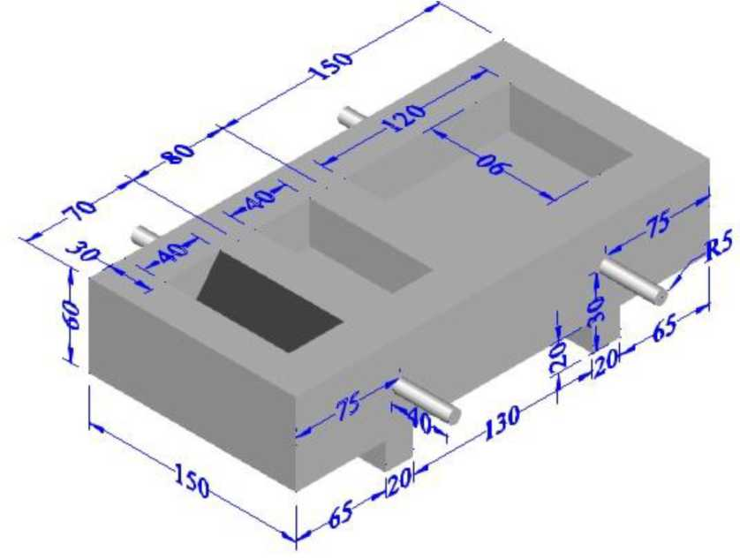

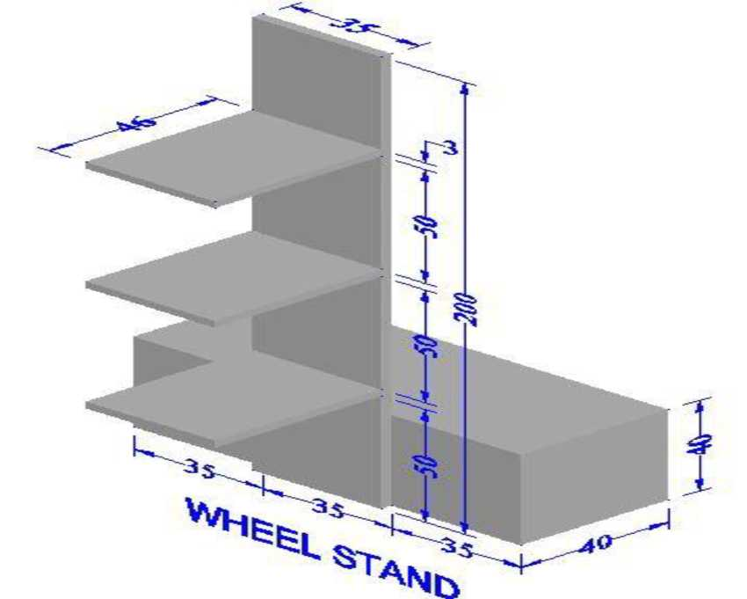

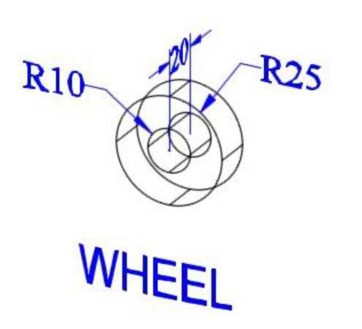

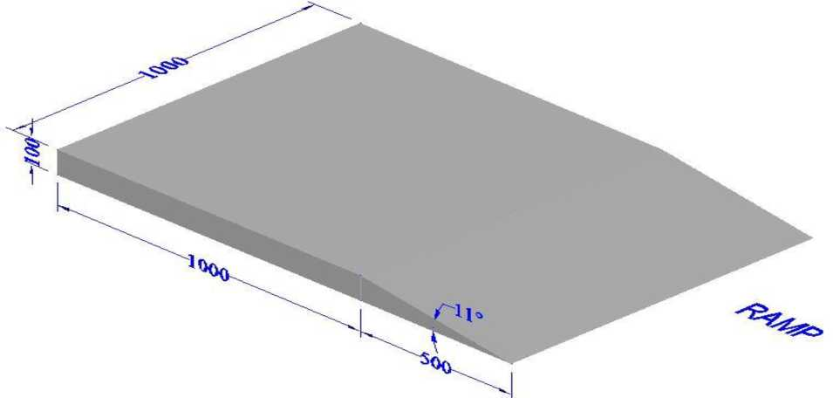

12
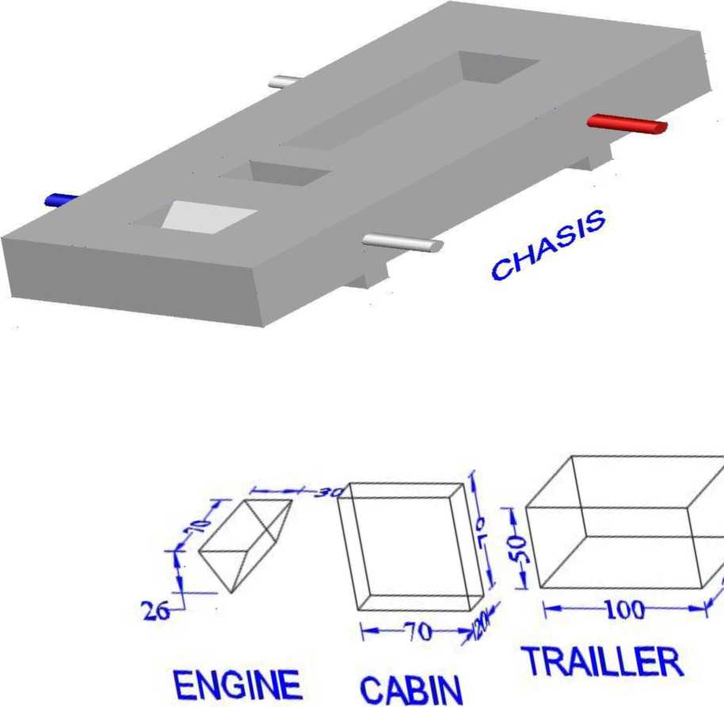

16.THE GAME FIELD DIAGRAM 2023 ROBOKEN
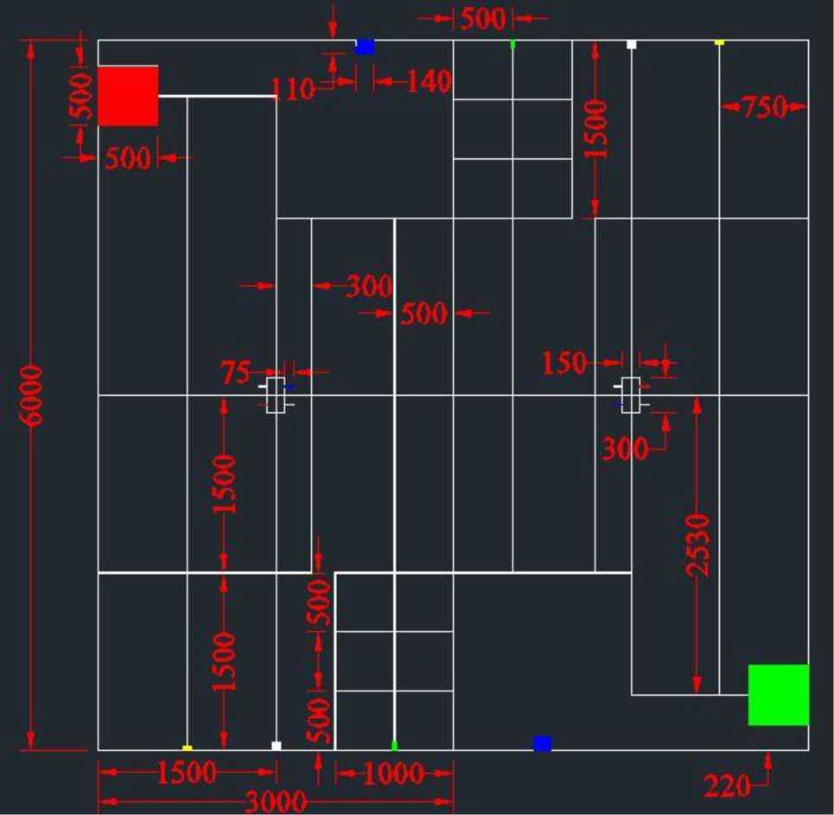

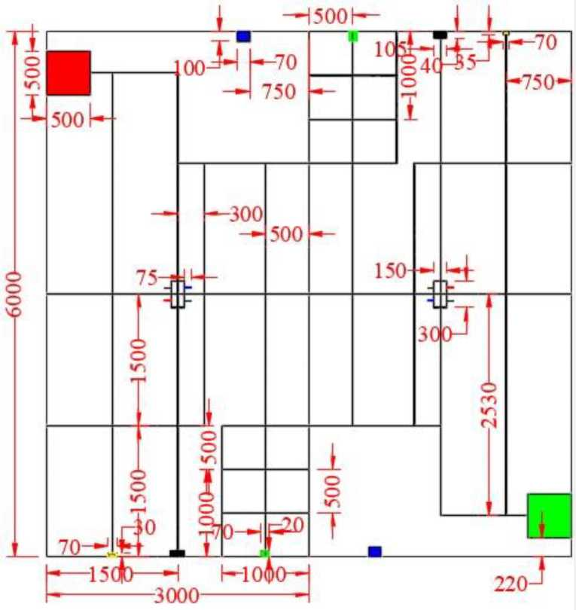

N/B: The Robot Game Field Scale: 1;1 All UNITS in mm
Blue is the Trailer
White is the Wheel rack
Yellow is the engine
Green on the ramp is the cabin
17. SCORING SHEET
ROBOKEN CONTEST 2023 SCORE SHEET
NAME OF THE INSTITUTION:
 | Task marks | Marks Scored- Game1 | Marks Scored- Game 2
A Team that has a Write-up | 5mks
A robot that successfully moves from start zone | 2mks
A robot that successfully moves from the starting zone to the engine picking zone | 2mks
A robot that successfully picks the Engine | 3mks
A robot that successfully moves with the engine to the chassis | 2mks
A robot that successfully places the engine on the chassis | 5mks
A robot that successfully moves to the wheel rack | 2mks
A robot that successfully picks the first white wheel | 3mks
A robot that successfully carries the first white wheel to the chassis | 2mks
A robot that successfully fits the first white wheel on the white part of the shaft on the chassis | 5mks
A robot that successfully picks the blue wheel | 3mks
A robot that moves to the chassis after successfully picking the blue wheel | 2mks
A robot that successfully fits the blue wheel on the blue part of the shaft on the chassis | 5mks
A robot that successfully picks the red wheel | 3mks
A robot that moves to the chassis after successfully picking the red wheel | 2mks
A robot that successfully fits the red wheel on the red part of the shaft on the chassis | 5mks
A robot that successfully picks the second white wheel | 3mks
A robot that moves to the chassis after successfully picking the second white wheel | 2mks
A robot that successfully fits the second white wheel on the white part of the shaft on the chassis | 5mks
A robot that successfully moves to the ramp | 2mks
A robot that successfully climbs the ramp | 5mks
A robot that successfully picks the cabin on the ramp | 3mks
A robot that successfully descends the ramp having successfully picked the cabin | 2mks
A robot that successfully moves to the chassis having successfully picked the cabin | 2mks

A robot that successfully fits the cabin on the chassis | 5mks
A robot that successfully moves to the trailer | 5mks
A robot that successfully picks the trailer | 3mks
A robot that successfully moves to the chassis having successfully picked the trailer | 5mks
A robot that successfully fits the trailer on the chassis | 5mks
A robot that successfully parks in its parking zone | 2mks
Total | 100
NB: The order of execution of tasks is at the discretion of the team during competition

18. WRITE -UP SCORE SHEET
Name of Institution:
Tasks | Marks Per Task | Marks Scored in Game 1 | Marks Scored in Game 2
Cover Page (Name of institution, Robot Name, Year of Competition, Logo) | i Mark
Lists (Lists of participants, Photos and names of participants, certified group photo; coloured, signed and rubber stamped) | i mark
Abstract (Summary of the project) | 1 Mark
Design and Construction (List of materials, Sample program, Schematic and Block diagrams and their descriptions) | 1 Mark
Operations | i Mark
Conclusion and Recommendations | i Mark
Budget | i Mark
References | i Mark

17

